DARSHAN EASE

Introduction:
Darshan Ease is a modern web-based temple darshan booking application developed to simplify the process of booking temple visits online. The platform allows devotees to explore temples, book darshan slots, participate in temple events, and manage their bookings from anywhere.
The system consists of three major user roles: Devotees (Users), Organizers, and Administrators. Administrators manage temples, events, and organizers. Organizers are responsible for creating and managing darshan slots for temples assigned to them. Devotees can browse temples, check available slots, and book darshan appointments conveniently.
By digitizing temple management and darshan booking, Darshan Ease minimizes overcrowding, reduces waiting time, and provides a smooth experience for devotees while helping temple authorities efficiently manage visitor flow.

Scenario Based Case Study:

Ramesh is a software engineer who wishes to visit Tirumala Temple during a festival season. Due to heavy crowds, obtaining darshan tickets through traditional methods becomes difficult and time-consuming. He also wants to know available darshan timings and upcoming temple events before planning his visit.
Temple administrators face challenges in handling thousands of devotees, managing temple information, organizing events, and assigning darshan slots. Organizers also need an efficient way to manage bookings and visitor limits.
Darshan Ease provides a centralized solution where devotees can book darshan tickets online, organizers can create booking slots, and administrators can manage temples, events, and users through a secure web application.

SYSTEM REQUIREMENTS :
To ensure smooth development, deployment, and usage of the House Hunt Web Application, certain system prerequisites must be met. These requirements are categorized into software, setup, and hardware specifications, all of which contribute to building a robust and scalable House Hunt platform.

1. Software Requirements
These are the essential tools and platforms required to develop, test, and run the application efficiently.
- Operating System: Windows 10/11, macOS, or Linux — Supports cross-platform development and testing.
- Node.js (v16 or above): Provides the runtime environment for building and managing frontend logic and Powers the server-side logic and handles API routing. 👉 Download Node.js
- npm (v8 or above): A package manager required to install dependencies for React and related libraries.
- React.js: A JavaScript library for building dynamic and responsive user interfaces.
- Browser: Google Chrome / Firefox (latest version) — For rendering and testing the UI in real-time.
- Express.js: A lightweight web framework for building RESTful APIs.
- MongoDB: A NoSQL database used to store structured and unstructured data related to users,Admin, Organizers 👉 Download MongoDB
- Postman: Tool for testing APIs during development.
- Visual Studio Code: Preferred code editor with built-in Git and terminal support.
- Git & GitHub: For version control and collaborative development.

2. Hardware Requirements
Describes the minimum and recommended specifications needed to support the development and usage of the application.
- Processor: Intel Core i5 (8th Gen or above) / AMD Ryzen 5 or better — Ensures fast compilation and multitasking during development.
- RAM: Minimum 8 GB (16 GB recommended) — For handling development servers, IDEs, and browser testing simultaneously.
- Storage: At least 1 GB free space — Required for package installations, MongoDB setup, and local project files.
- Display: 1366x768 or higher — Recommended for optimal coding experience and application layout visualization.

PROJECT ARCHITECTURE

Technical Architecture:

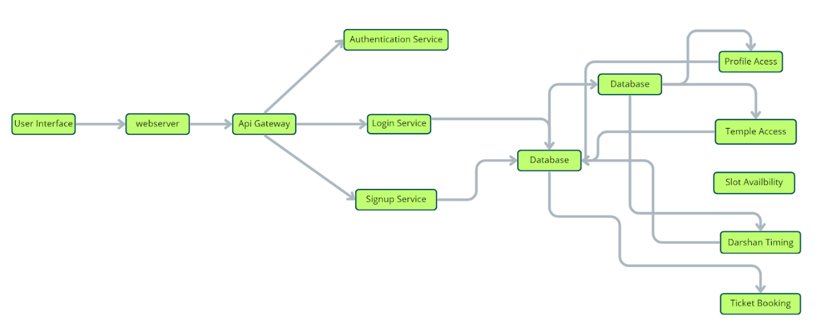
User Interface
Provides separate dashboards for Devotees, Organizers and Admin.
Web Server
Hosts frontend and backend services.
Authentication Service
Handles secure login and role-based authentication.
Temple Service
Manages temples and temple information.
Event Service
Handles temple events.
Slot Management Service
Allows organizers to create darshan slots.
Booking Service
Processes ticket bookings.
Admin Service
Controls organizers, temples, events and users.
Database
Stores users, temples, bookings, events and slots.

- ER-Diagram:
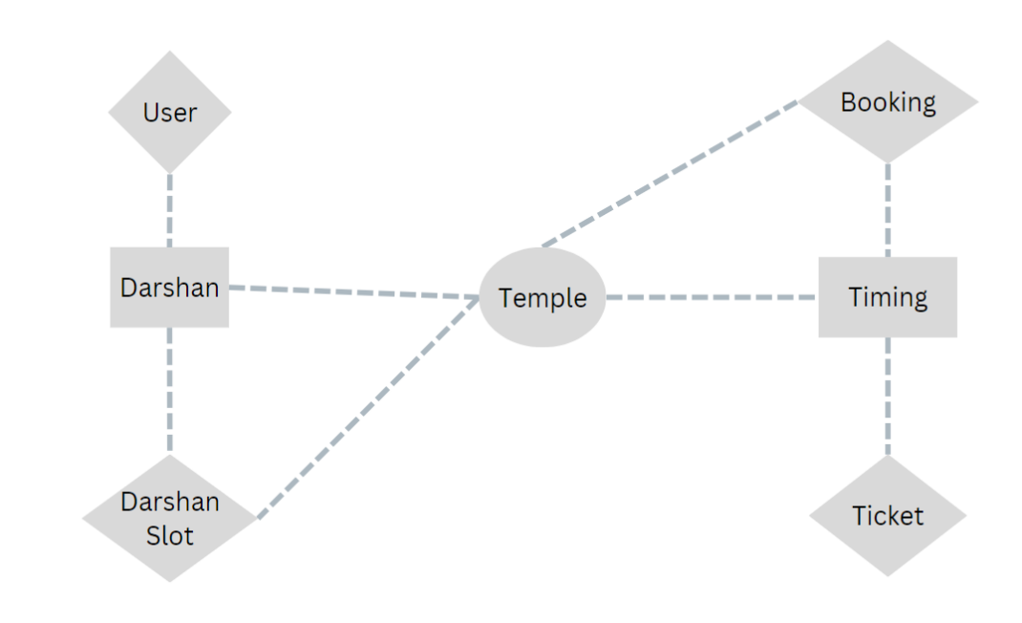

User:
UserID (PK)
Name
Email
Phone
Address
Temple:
TempleID (PK)
TempleName
Location
DarshanStartTime
DarshanEndTime
DarshanSlot:
SlotID (PK)
TempleID (FK)
Date
StartTime
EndTime
AvailableSeats
Price

Booking:
BookingID (PK)
UserID (FK)
SlotID (FK)
BookingDate
TotalAmount

The relationships between the entities are as follows:
User-Booking Relationship: One-to-Many relationship between User and Booking (One user can make multiple bookings)
Foreign Key: UserID in Booking
Temple-DarshanSlot Relationship: One-to-Many relationship between Temple and DarshanSlot (One temple can have multiple darshan slots)
Foreign Key: TempleID in DarshanSlot
Booking-DarshanSlot Relationship: One-to-Many relationship between DarshanSlot and Booking (One darshan slot can have multiple bookings)
Foreign Keys: SlotID in Booking, TempleID in DarshanSlot
The foreign key relationships are established between the entities using the primary keys from the respective tables.

Key Features:
Devotee Registration and Authentication: Enable devotees to register accounts, log in securely, and authenticate their identity to access the temple darshan ticket booking system.
Darshan Listings: Display a comprehensive list of available darshan slots with details such as temple name, location, darshan date, and timings.
Temple Selection: Provide a selection of temples offering darshan slots, including detailed information about each temple's location and unique darshan offerings.
Slot Selection: Allow devotees to choose their preferred darshan slots from the available options, showcasing the layout of the temple and available slots.
Ticket Booking: Empower devotees to book tickets for a specific darshan slot, specifying the number of devotees accompanying them.
Donation Integration: Integrate with a secure payment gateway to facilitate online donations and contributions along with the darshan ticket booking.
Booking Confirmation: Provide devotees with a confirmation page or email containing the details of the darshan booking, including darshan slot information and booking ID.
Booking History: Allow devotees to view their past and upcoming darshan bookings, offering options to cancel or modify bookings if allowed by the temple.
Darshan Slot Availability Tracking: Keep track of the availability of darshan slots for each temple and update in real-time as slots are booked or canceled.
Organizer Dashboard: Provide temple Registration with an interface to manage temple, darshan slots, devotees, availability, and booking-related activities.
Darshan Slot Management: Organizer is responsible ticket issueing and slot booking.
Admin Dashboard: Provide temple administrators with an interface to manage users, organizers,temples, darshan slots, devotees, availability, and booking-related activities.
Reporting and Analytics: Generate reports and analytics on darshan bookings, popular temples, devotee demographics, and other relevant metrics to gain insights into the temple's activities.

Roles and Responsibility
User:-

Registration: Devotees are responsible for creating an account on the Temple Darshan Ticket Booking App by providing necessary details like name, email, and password.

Profile Management: Devotees have access to manipulate their profiles, allowing them to update information such as email, name, and password.

Darshan Booking: Devotees can view available darshan slots, book specific slots, and acquire electronic tickets for their temple visits.

Feedback: Provide feedback and ratings for the darshan experience.

Logout: Finally, they can logout from the DarshanEase.

Organizer:-

Profile Management: Temple organizers have access to manipulate their profiles, allowing them to update information such as email, name, and password.

Darshan Slot Management: Temple organizers are responsible for managing darshan slots, including scheduling, updating availability, and marking special slots.

Booking Management: Temple organizers can view and manage darshan bookings, assign slots, and make adjustments as necessary.

Notification Handling: Receive notifications related to darshan bookings and updates for efficient communication with devotees.

Logout: Finally, they can logout from the DarshaEase.

Admin:-

System Management: Admins have full control over all aspects of the temple darshan ticket booking system, overseeing functionalities, configurations, and security.

Devotee Management: Admins can manipulate devotee information, including creating, updating, and deleting accounts. They also have the authority to manage darshan ratings.
Temple Organizer Management: Admins can manipulate temple organizer information, including creating, updating, and deleting accounts.
Facility Management: Admins can schedule darshan slots, allocate resources efficiently, and handle maintenance requests for the temple.

Events Management: Admins have the authority to create and manage temple events, including scheduling and deleting events.

Logout: Finally, they can logout from the DarshaEase.

User Flow:
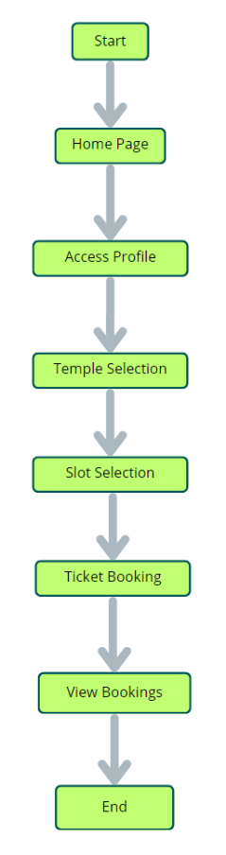

Start: The process begins as users enter the Temple Darshan Ticket Booking App.

Home Page: Users land on the home page, providing an overview of the temple darshan ticket booking services. From here, they can initiate various actions.

Access Profile: Users have the option to access their profiles, allowing them to view or update personal information, preferences, and past booking history.
Temple Selection:After accessing their profiles, users proceed to select a specific temple for darshan. The app presents a list of available temples, along with relevant details.

Slot Selection: Users navigate through the available darshan slots for the selected temple. They can view darshan timings, slot availability, and choose a preferred time slot for their visit.

View Bookings: Users have the option to view their current and past darshan bookings. This section provides details about booked slots, confirmation status, and electronic tickets.

Ticket Booking: For new bookings, users can initiate the ticket booking process. This involves selecting a temple, choosing a darshan slot, confirming the booking, and receiving an electronic ticket.

End: The flow concludes as users have completed their desired actions within the
This flowchart outlines the user journey within the app, starting from the home page, navigating through profile and temple selections, managing bookings, and concluding with the booking process or other activities, ultimately providing a seamless experience for DarshanEase.

MVC Pattern :

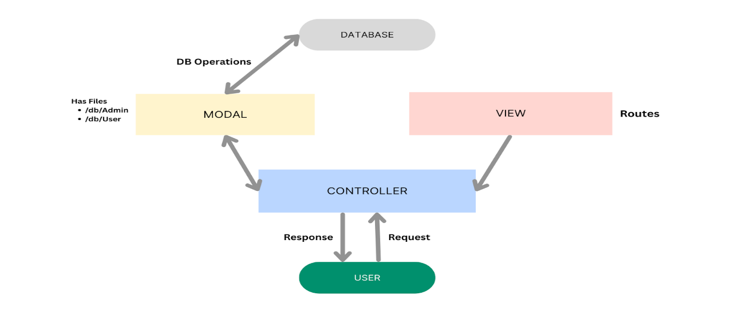
The Darshan Ease backend application follows the Model-View-Controller (MVC) architectural pattern, a software design approach that separates an application into three interconnected layers. This separation allows for modularity, easier maintenance, and scalability.
Model Layer (Data Layer)
The Model layer is responsible for handling all data-related logic. This includes the definition of data schemas and the operations performed on the database using those schemas. The models are implemented using Mongoose, which provides a schema-based solution to model application data for MongoDB.
Controller Layer
The Controller layer acts as an intermediary between the view (routes) and the model. It receives incoming requests, processes the input (which may include validation or transformation), calls the appropriate methods from the model, and then returns a response to the client.

View Layer (Routing Layer)
In the context of a backend REST API, the View is implemented as the routing layer, where various endpoints are defined. These endpoints determine how the backend responds to different HTTP requests (GET, POST, PUT, DELETE) and are responsible for invoking the appropriate controller functions.

Advantages of Using MVC in This Project

Separation of Concerns: Each layer has a clearly defined responsibility, improving readability and maintainability.
Scalability: New features can be added easily by creating new routes, controllers, and models.
Reusability: Logic in controllers and models can be reused across multiple parts of the application.
Testing: Each layer can be tested independently, especially the controllers and models.
Collaboration-Friendly: Multiple developers can work simultaneously on different layers without conflict.

PROJECT SETUP AND CONFIGURATION :

- Creating project folder
1. Create a new folder with your DarshanEase.
2. Inside that folder create two new folders.
3. Name one as **Client**.
4. Name another one as **Server**.
5. Now open that folder in VS Code.
- Client setup (installing react app)
  - Open the Client folder in the terminal of VScode.
    - npm create vite@latest . -- --template react
  - Select React framework from the given options.
    - Select a framework:
    - │ React
  - Select JavaScript variant from the given options.
    - Select a variant:
    - │ JavaScript
  - Now lets navigate to the client folder by giving the following command.
    - cd client
  - To install all the packages run the following command.
    - npm install
  - To start the React server type the following command.
    - npm run dev

- Server setup (npm init)
  - Open Server folder in terminal of VScode.
    - npm init -y
  - Create files:
    - server.js
  - Create folders:
    - models
    - controllers
    - routes
BACKEND DEVELOPMENT:
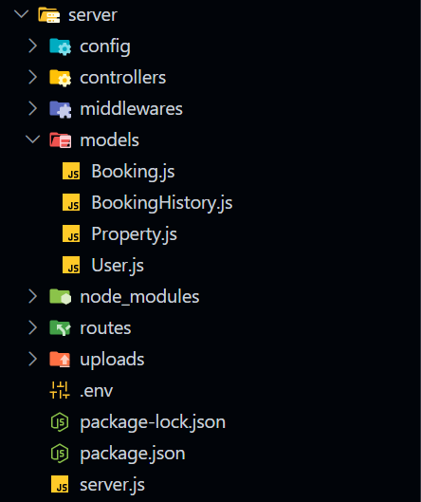

- Setup express server
- Create index.js file in the server (backend folder).
- Create a .env file and define port number to access it globally.
- Configure the server by adding cors, body-parser.

- User Authentication:
  - Create routes and middleware for user registration, login, and logout.
  - Set up authentication middleware to protect routes that require user authentication.

- Define API Routes:
  - Create separate route files for different API functionalities such as users orders, and authentication.
  - Define the necessary routes for listing products, handling user registration and login,managing orders, etc.
  - Implement route handlers using Express.js to handle requests and interact with the database.

- Implement Data Models:
  - Define Mongoose schemas for the different data entities like products, users, and orders.
  - Create corresponding Mongoose models to interact with the MongoDB database.
  - Implement CRUD operations (Create, Read, Update, Delete) for each model to perform database operations.

- User Authentication:
  - Create routes and middleware for user registration, login, and logout.
  - Set up authentication middleware to protect routes that require user authentication.

- Error Handling:
• Implement error handling middleware to catch and handle any errors that occur during the API requests.
• Return appropriate error responses with relevant error messages and HTTP status codes.

Reference Video :
https://drive.google.com/drive/folders/11D6w_4wOQ6RTRG0JI9ie9KxPRYf-vzuD
Database Development :

1. Configure MongoDB:
- Install Mongoose.
- Create database connection.
- Create Schemas & Models.

2. Connect database to backend:
Now, make sure the database is connected before performing any of the actions through the backend. The connection code looks similar to the one provided below.
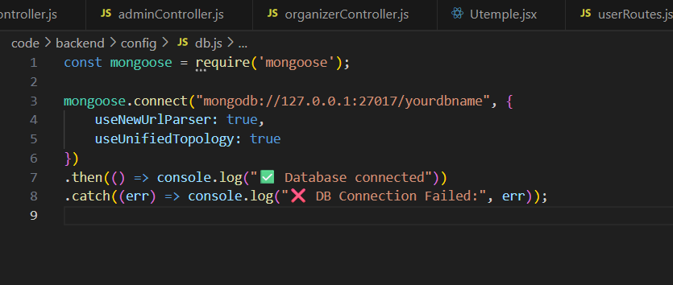

3. Configure Schema:

Firstly, configure the Schemas for MongoDB database, to store the data in such pattern. Use the data from the ER diagrams to create the schemas.
The schemas are looks like for the Application.

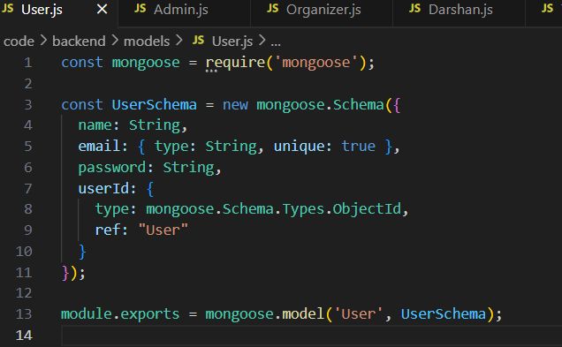

ReferenceVideo:
https://drive.google.com/drive/folders/11D6w_4wOQ6RTRG0JI9ie9KxPRYf-vzuD

Front-End Development.
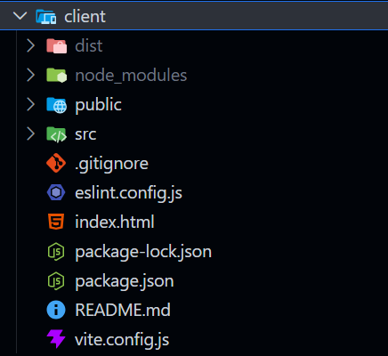

1. Setup React Application:
• Create React application.
• Configure Routing.
• Install required libraries.

2. Design UI components:
• Create Components.
• Implement layout and styling.
• Add navigation.

3. Implement frontend logic:
• Integration with API endpoints.
• Implement data binding.

Project Execution

- Steps for Project execution
Step 1: Set Up the Frontend (React App):
a) Open a terminal and navigate into the client folder:
cd client
b) Once installation is done, start the React development server:
npm run dev
c) The app should now be running on:
http://localhost:5173

Step 2: Set Up the Backend (Express Server)

a) Open a new terminal tab/window or split the terminal.

b) Navigate into the server folder:
cd ../server

Step 3: Configure Environment Variables

- Inside the server folder, create a new file named .env (no file extension).
- In that .env file, add your MongoDB connection string:
MONGO_URI=mongodb://localhost:7000/house hunt

Step 4: Start the Backend Server:

- Inside the same server folder, run the backend server using:
nodemon index.js
- The server should start on:
http://localhost:8000

OUTPUT SCREENSHOTS:
Finally, after finishing coding the projects we run the whole project to test it’s working process and look for bugs. Now, let’s have a final look at the working of our Darshan Ease.

Landing page:-
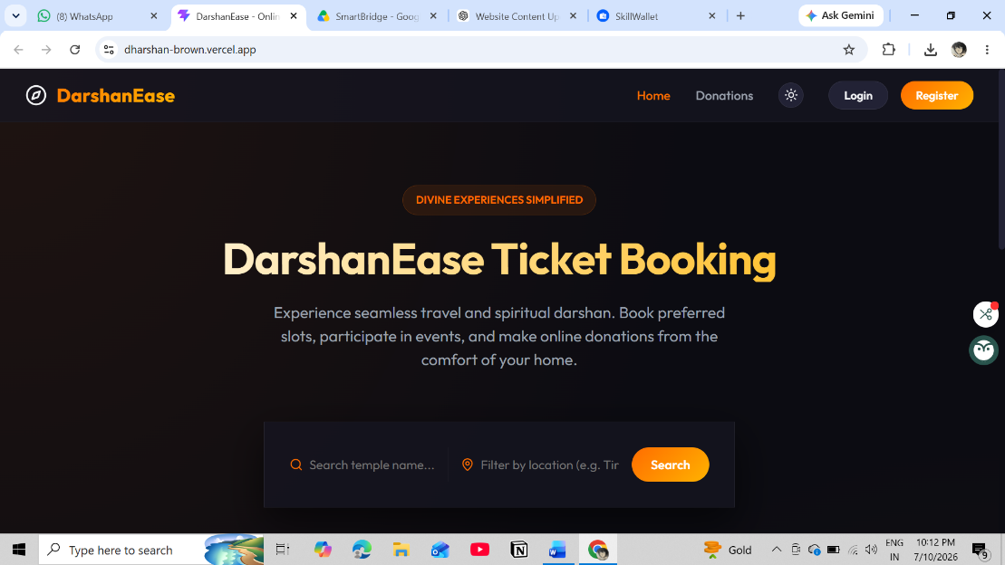

Login Page:-
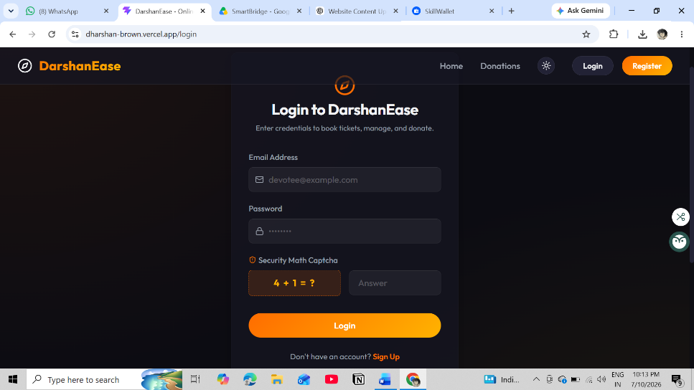

Temples:
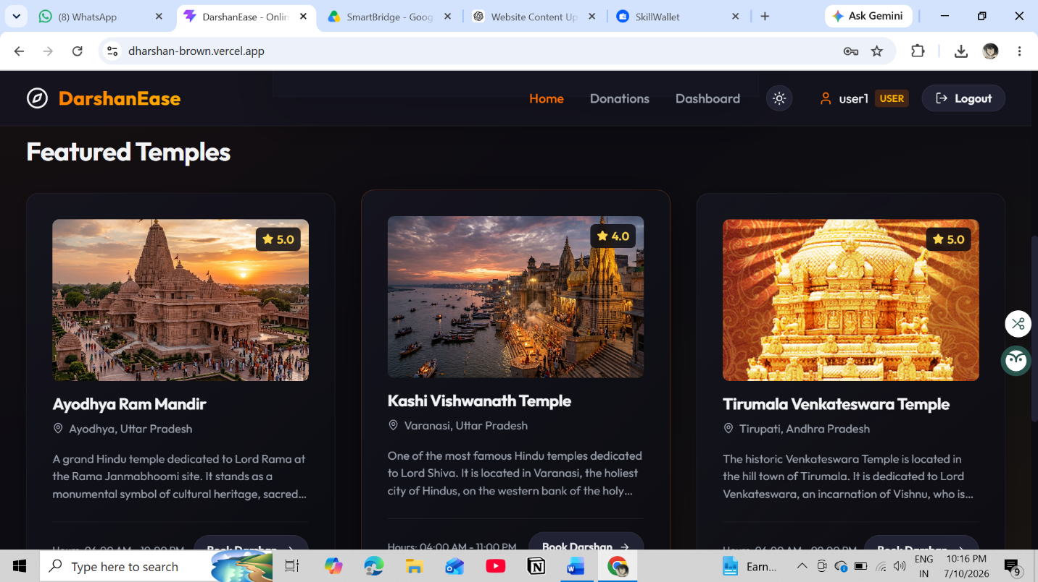
Booking page:
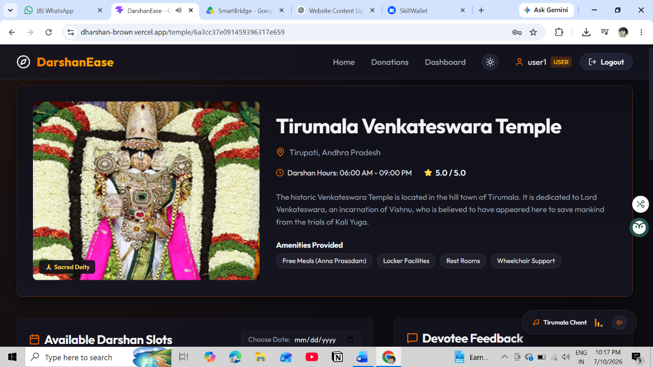

Booking Details
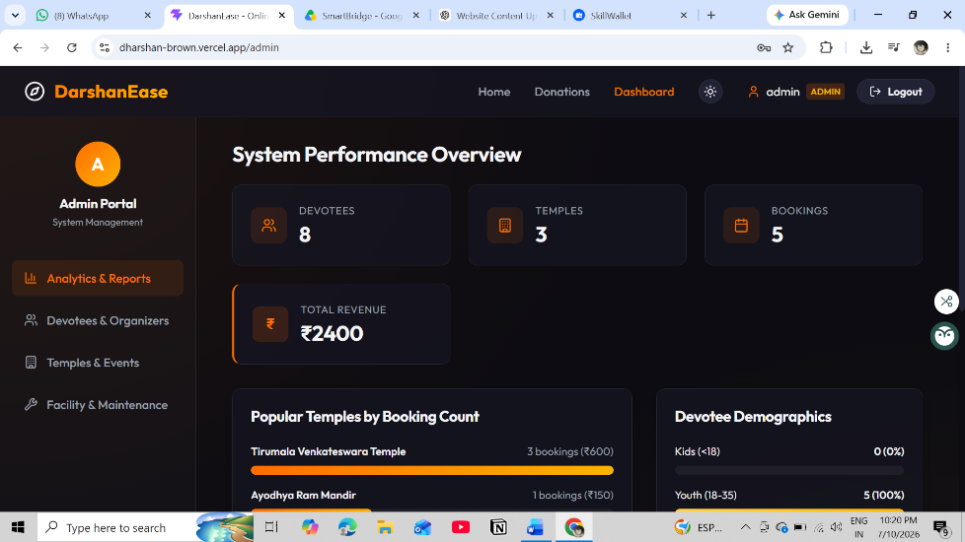
AdminPage:
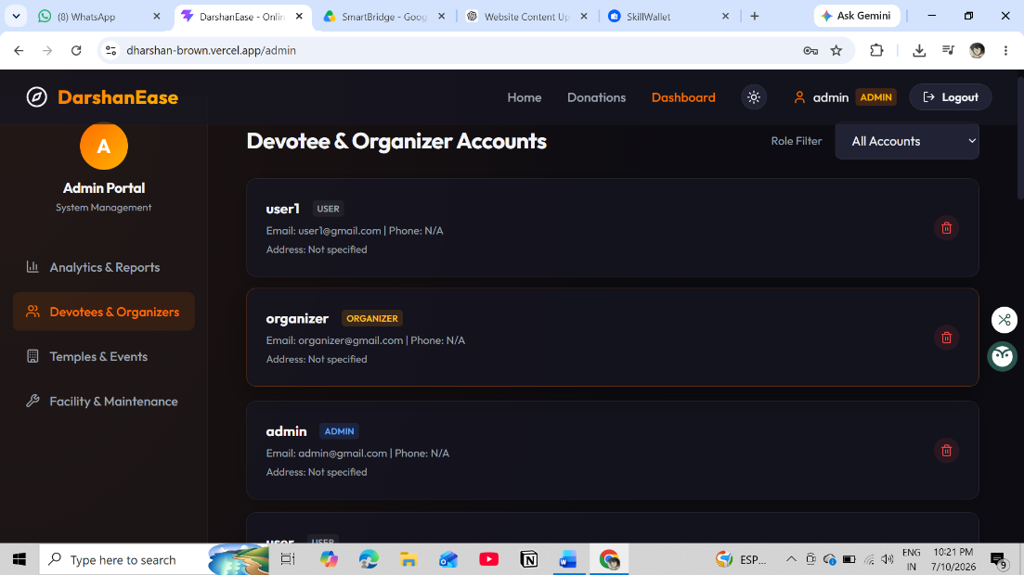
Admin AddingPage:
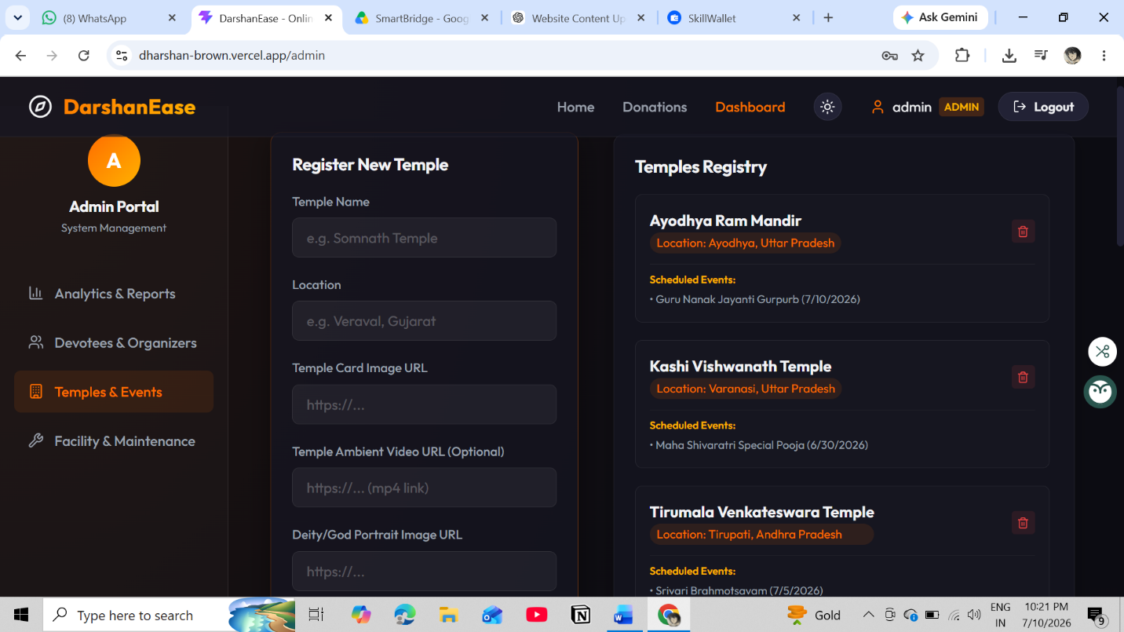

The demo of the app is available at:-
https://dharshan-brown.vercel.app/
Code :
https://github.com/MDeepak23/dharshan

*** HappyCoding!! ***

